PCB

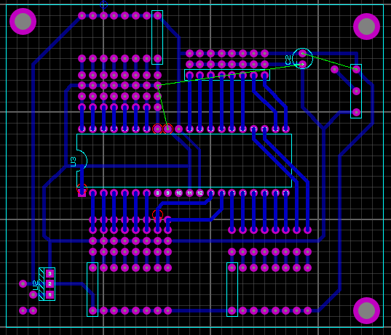

DISEÑO

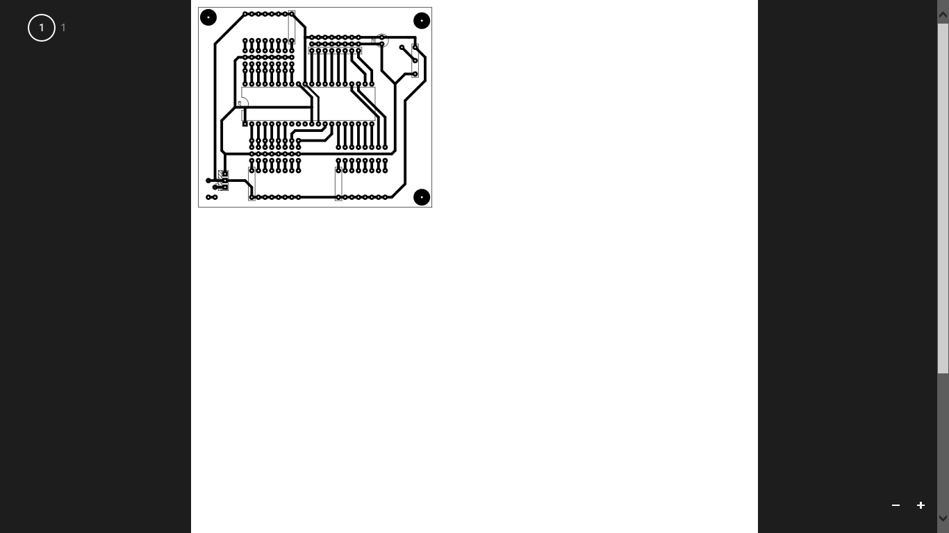

VISTA 3D

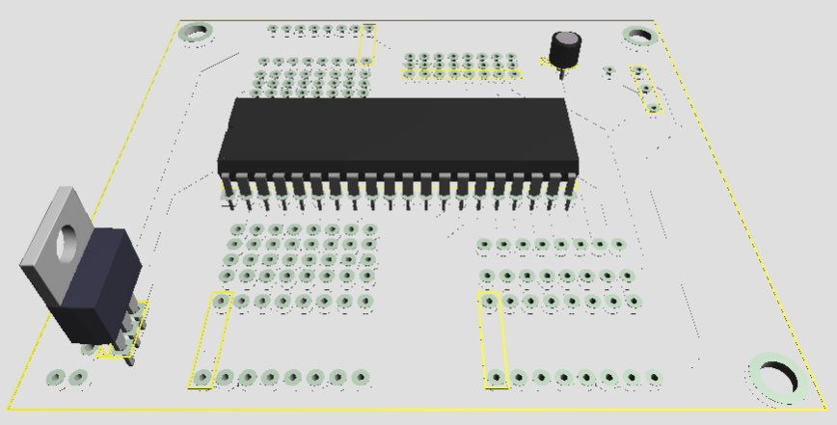

SIMULACION

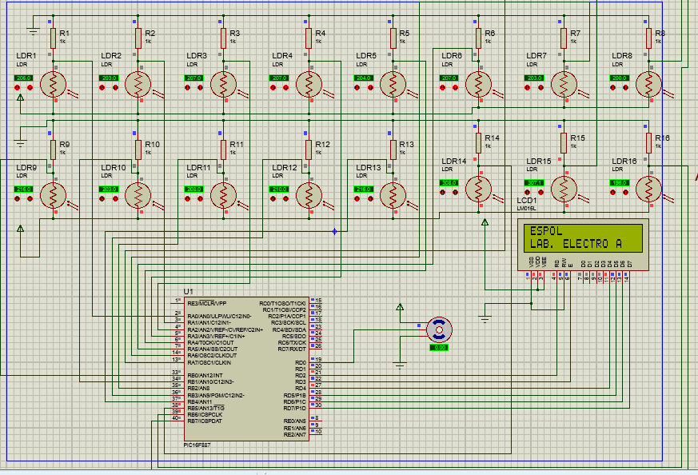

CODIGO

program Control_parqueo

dim LCD_RS as sbit at RD2_bit

LCD_EN as sbit at RD3_bit

LCD_D4 as sbit at RD4_bit

LCD_D5 as sbit at RD5_bit

LCD_D6 as sbit at RD6_bit

LCD_D7 as sbit at RD7_bit

LCD_RS_Direction as sbit at TRISD2_bit

LCD_EN_Direction as sbit at TRISD3_bit

LCD_D4_Direction as sbit at TRISD4_bit

LCD_D5_Direction as sbit at TRISD5_bit

LCD_D6_Direction as sbit at TRISD6_bit

LCD_D7_Direction as sbit at TRISD7_bit

DIM CONT1,CONT2,CONT3,CONT4,CONT5,CONT6,CONT7,CONT8,CONT9,CONT10,CONT11,CONT12,CONT13,CONT14,CONT15,por,giro AS BYTE

DIM ACUMULADOR AS BYTE

DIM TEXTO AS STRING [5]

sub procedure abrir()

dim i as longword

i=0

while (i<10000)

inc(i)

if INTCON.TMR0IF=1 THEN

if por=1 then

giro=109

por=2

PORTD.RD0=0

GOTO final

end if

if por=2 then

giro=243

por=1

PORTD.RD0=1

GOTO final

end if

final:

TMR0 = giro

INTCON = 0x20

end if

wend

end sub

sub procedure cerrar()

dim i as longword

i=0

while (i<10000)

inc(i)

if INTCON.TMR0IF=1 THEN

if por=1 then

giro=114

por=2

PORTD.RD0=0

GOTO final

end if

if por=2 then

giro=238

por=1

PORTD.RD0=1

GOTO final

end if

final:

TMR0 = giro

INTCON = 0x20

end if

wend

End sub

main:

OSCCON = 0X65

OPTION_REG=0X06

PORTA = %00000000

TRISA = %11111111

PORTB = %00000000

TRISB = %11111111

PORTC = %00000000

TRISC = %00000000

PORTD = %00000000

TRISD = %00000000

PORTE = %00000000

TRISE = %00000000

ANSEL = %00000000

ANSELH = %00000000

INTCON = 0XC0

PIR1.RCIF=0

PIE1.RCIE=1

por=2

TMR0=100

CONT1 =0

CONT2 =0

CONT3 =0

CONT4 =0

CONT5 =0

CONT6 =0

CONT7 =0

CONT8 =0

CONT9 =0

CONT10 =0

CONT11 =0

CONT12 =0

CONT13 =0

CONT14 =0

CONT15 =0

Lcd_Init()

Lcd_Cmd(_LCD_CLEAR)

Lcd_Cmd(_LCD_CURSOR_OFF)

Lcd_Out(1,1,"ESPOL")

Lcd_Out(2,1,"LAB. ELECTRO A")

Delay_ms(1000)

Lcd_Cmd(_LCD_CLEAR)

''''''''''''''''''''''''''''''

Lcd_Out(1,1,"CONTROL DE ")

Lcd_Out(2,1,"PARQUEO")

Delay_ms(1000)

''''''''''''''''''''''''''''

Lcd_Cmd(_LCD_CLEAR)

Delay_ms(1000)

while 1

ACUMULADOR=0

Lcd_Out(1,1,"LIBRES: ")

Lcd_Out(2,1,"OCUPADOS: ")

if PORTA.RA0 = 0 then CONT1 = 0 ELSE CONT1 = 1 end if

if PORTA.RA1 = 0 then CONT2 = 0 ELSE CONT2 = 1 end if

if PORTA.RA2 = 0 then CONT3 = 0 ELSE CONT3 = 1 end if

if PORTA.RA3 = 0 then CONT4 = 0 ELSE CONT4 = 1 end if

if PORTA.RA4 = 0 then CONT5 = 0 ELSE CONT5 = 1 end if

if PORTA.RA5 = 0 then CONT6 = 0 ELSE CONT6 = 1 end if

if PORTA.RA6 = 0 then CONT7 = 0 ELSE CONT7 = 1 end if

if PORTA.RA7 = 0 then CONT8 = 0 ELSE CONT8 = 1 end if

if PORTB.RB0 = 0 then CONT9 = 0 ELSE CONT9 = 1 end if

if PORTB.RB1 = 0 then CONT10 = 0 ELSE CONT10 = 1 end if

if PORTB.RB2 = 0 then CONT11 = 0 ELSE CONT11 = 1 end if

if PORTB.RB3 = 0 then CONT12 = 0 ELSE CONT12 = 1 end if

if PORTB.RB4 = 0 then CONT13 = 0 ELSE CONT13 = 1 end if

if PORTB.RB5 = 0 then CONT14 = 0 ELSE CONT14 = 1 end if

if PORTB.RB6 = 0 then CONT15 = 0 ELSE CONT15 = 1 end if

ACUMULADOR = CONT1 +CONT2 +CONT3 +CONT4 +CONT5 +CONT6 +CONT7 +CONT8 +CONT9 +CONT10 +CONT11 +CONT12 +CONT13 +CONT14 +CONT15

ByteToStr(ACUMULADOR, TEXTO)

Lcd_Out(1,10,TEXTO)

ByteToStr(15-ACUMULADOR, TEXTO)

Lcd_Out(2,10,TEXTO)

Delay_ms(1000)

if ACUMULADOR = 0 THEN

Lcd_Out(1,1,"PARQUEADERO ")

Lcd_Out(2,1,"LLENO ")

Delay_ms(1000)

Lcd_Cmd(_LCD_CLEAR)

Lcd_Out(1,1,"INGRESO ")

Lcd_Out(2,1,"BLOQUEADO ")

Delay_ms(1000)

Lcd_Cmd(_LCD_CLEAR)

CERRAR()

else

if PORTB.RB7=0 then

ABRIR()

Lcd_Out(1,1,"INGRESO ")

Lcd_Out(2,1,"PERMITIDO ")

Delay_ms(1000)

Delay_ms(1000)

CERRAR()

Delay_ms(1000)

Lcd_Cmd(_LCD_CLEAR)

end if

end if

Delay_ms(1000)

wend

end.